* Insert data into the travel_db database with this command.
  + NOTE: This will also create the collection automatically, the contents of the insert are basically a JavaScript object, and include an array.

db.destinations.insert({"continent": "Africa", "country": "Morocco",

"major_cities": ["Casablanca", "Fez", "Marrakech"]})

* Find all data in a Collection with db.[COLLECTION_NAME].find()
  + The MongoDB _id was created automatically.
  + This id is specific for each doc in the collection.

db.destinations.find()

use classDB

db.classroom.insert({name: 'Mariah', age: 23, favorite_python_library: 'Seaborn', hobbies: ['Coding', 'Reading', 'Running']})

db.classroom.find({age: 23}).pretty()

* Show how to update data using db.[COLLECTION_NAME].update()

db.destinations.update({"country": "Egypt"}, {$set: {"continent": "Antarctica"}})

* To update multiple entries, you can add {multi:true}, all countries listed as being in Africa will now show Antarctica as their continent

db.destinations.update({"continent": "Africa"}, {$set: {"continent": "Antarctica"}}, {multi: true})

* Show how to drop a database

db.dropDatabase()

db.divers.remove({"name":"Boppo"})

# The default port used by MongoDB is 27017 # <https://docs.mongodb.com/manual/reference/default-mongodb-port/>

conn = 'mongodb://localhost:27017'

client = pymongo.MongoClient(conn)

# Define the 'classDB' database in Mongo

db = client.classDB

# Query all students

# Here, db.students refers to the collection 'classroom '

classroom = db.classroom.find()

# Iterate through each student in the collection

for student in classroom:

print(student)

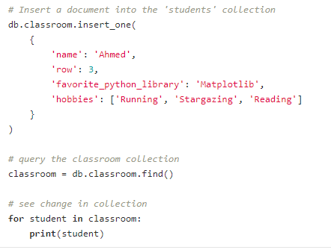

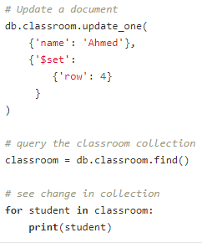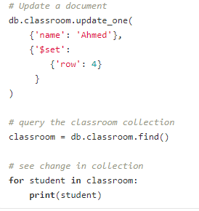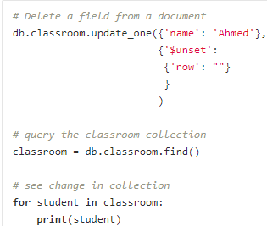

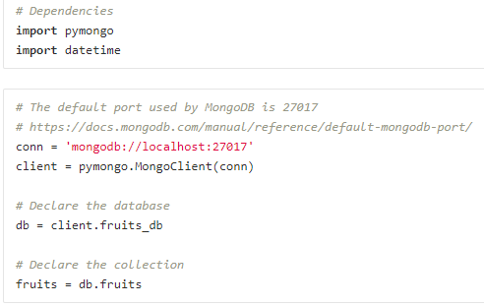

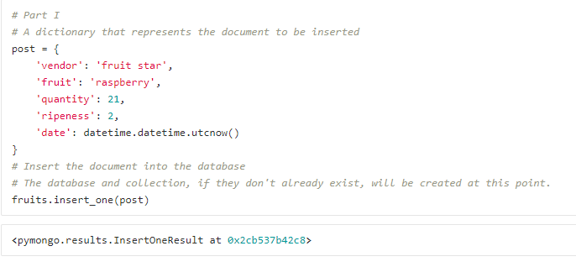

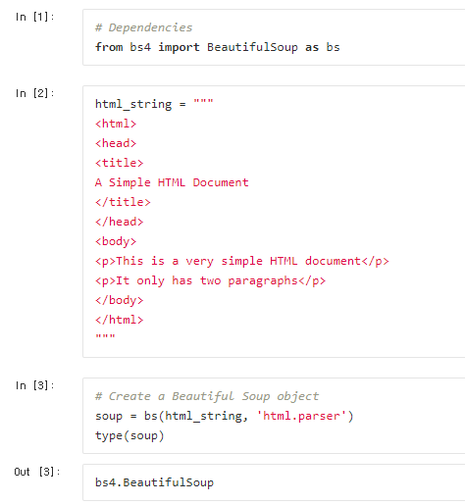

**What difference soup = bs(html. ‘lxml’) vs bs(html_string, ‘html.parser’)**

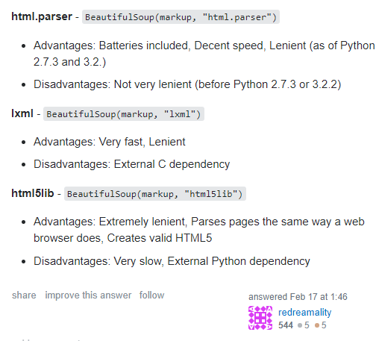

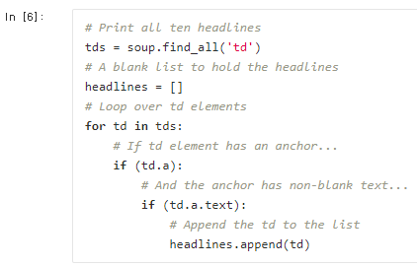

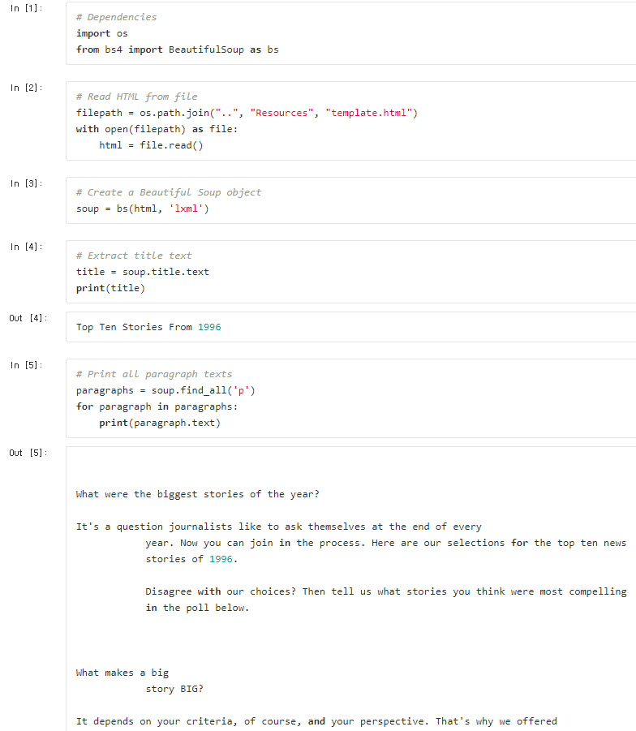

Ins_Craigslist

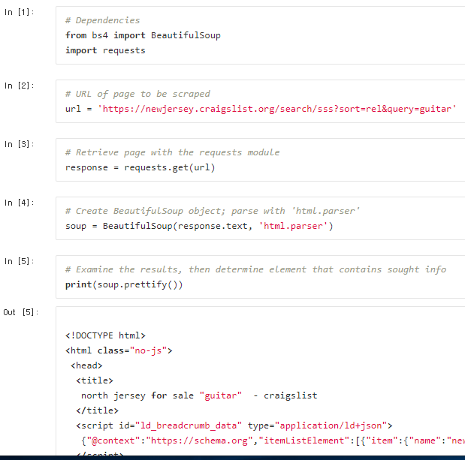

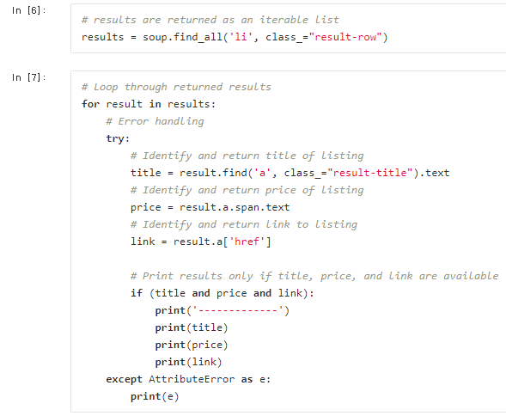 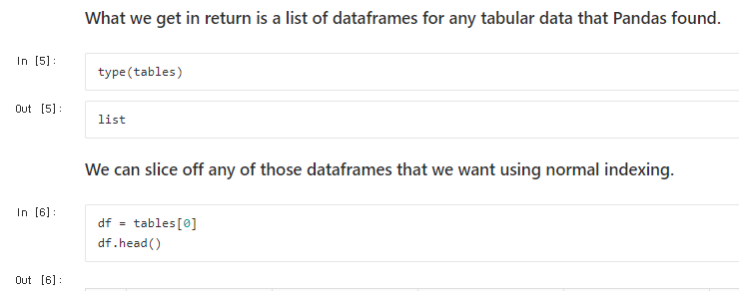 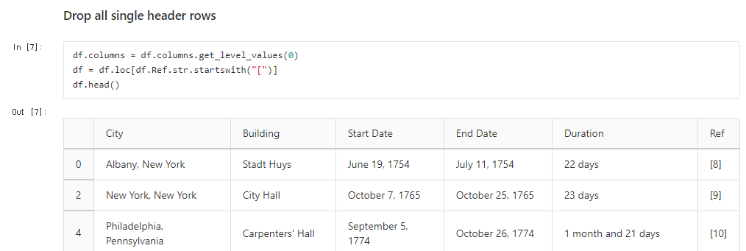

What is this df = df.loc[df.Ref.str.startswith(“[“]) ??

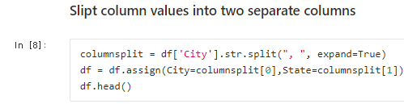

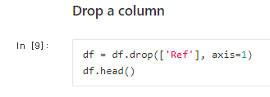

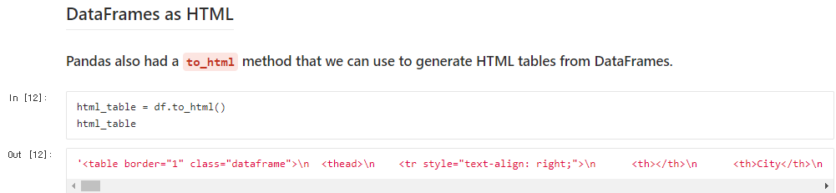

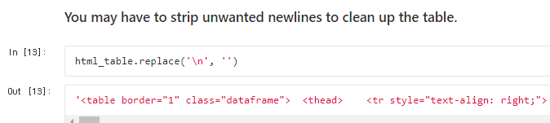

**Html -> pandas -> html**

